**TEAM CHARIS Project As-Built: Azure CLI and Bicep**

**📘 Overview**

This guide outlines a modular Azure infrastructure deployment using **Azure CLI** and **Bicep templates**. It enforces VM SKU compliance with **Azure Policy**, provisions a networked virtual machine, storage account, and Log Analytics workspace, and leverages best practices for reusable Infrastructure as Code (IaC).

**🧰 Prerequisites**

Ensure the following tools are ready:

* **Azure CLI installed (az version)**

1. **Prepare Environment and Tools**

**Bicep CLI installed:**

**🏗️ Resource Group Setup**

🔒 **Enforce Allowed VM SKU via Policy**

**Create policy-rules.json:**

**Create policy definition:**

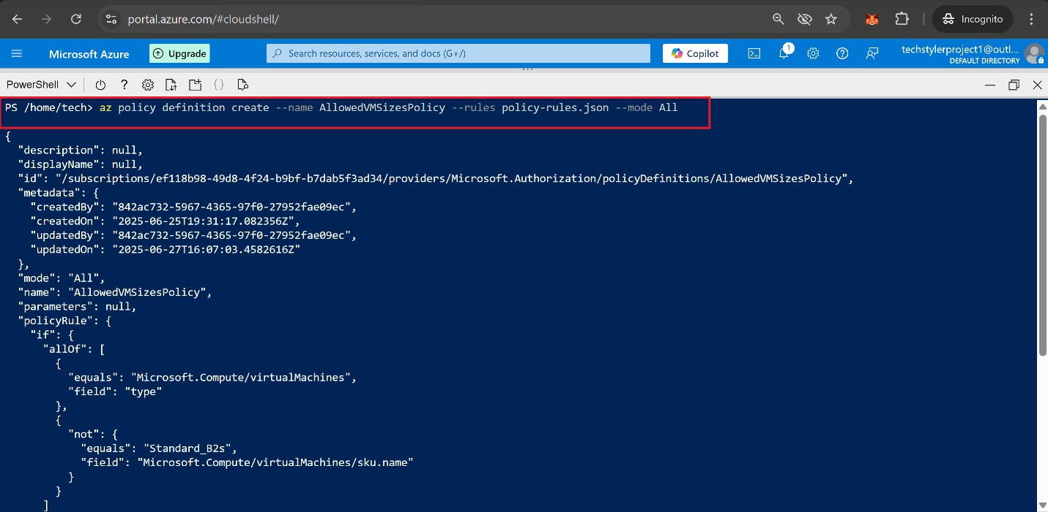

**Assign the policy to your resource group:**

**🧩 Bicep Modules Overview**

**💡 Place all .bicep files in the same folder for simplicity.**

* 1. **Create resources.bicep file:**

Virtual Network, Subnet, NSG, NIC, Public IP, and VM

1. **Create storage.bicep file:**

Storage Account (StorageV2)

1. **Create monitor.bicep file:**

Log Analytics Workspace

1. **Create deploy-all.bicep file:**

Orchestration of all modules + additional VM resource block

**🚀 Deploy-All in One Command**

**Confirmation of all resources deployed in azure portal**

